**WEB APPLICATION PART 3**

1. **Link to the GitHub Repository**

<https://github.com/dhavaldp96/WebAppPart3.git>

1. **Screenshots**
2. The project showing that you can view ***YOUR*** data tables in PyCharm

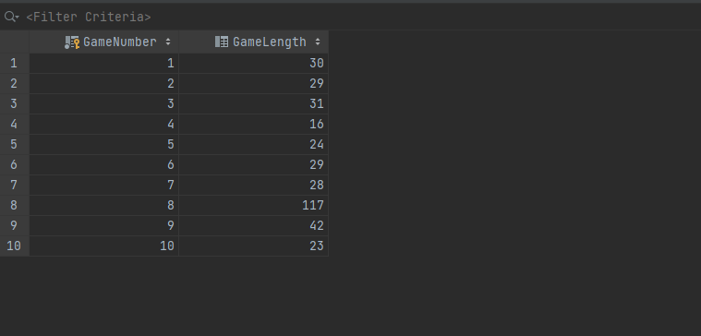

1. ***YOUR*** project running correctly in the browser displaying homepage with your data

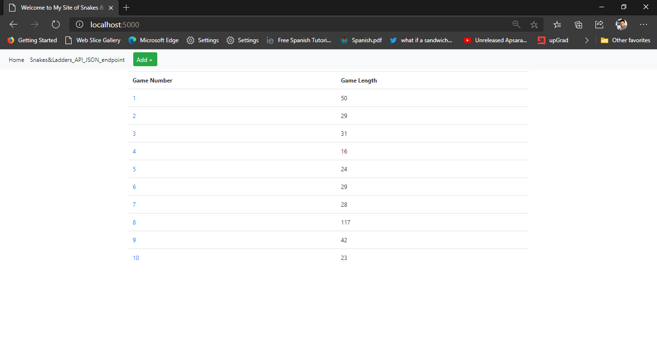

1. ***YOUR*** project running correctly in the browser displaying your data record as a view of one record

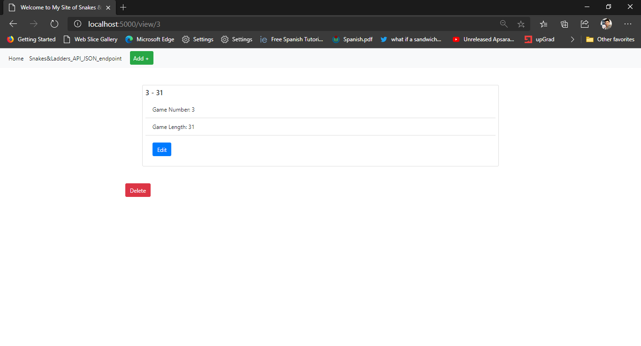

1. ***YOUR*** project running correctly in the browser displaying a new record added to your home page

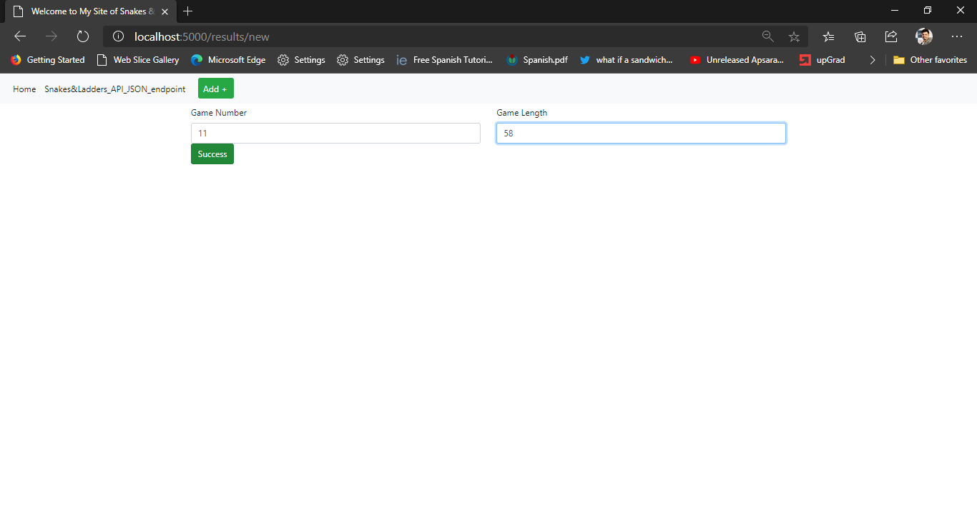

*After adding a new record*

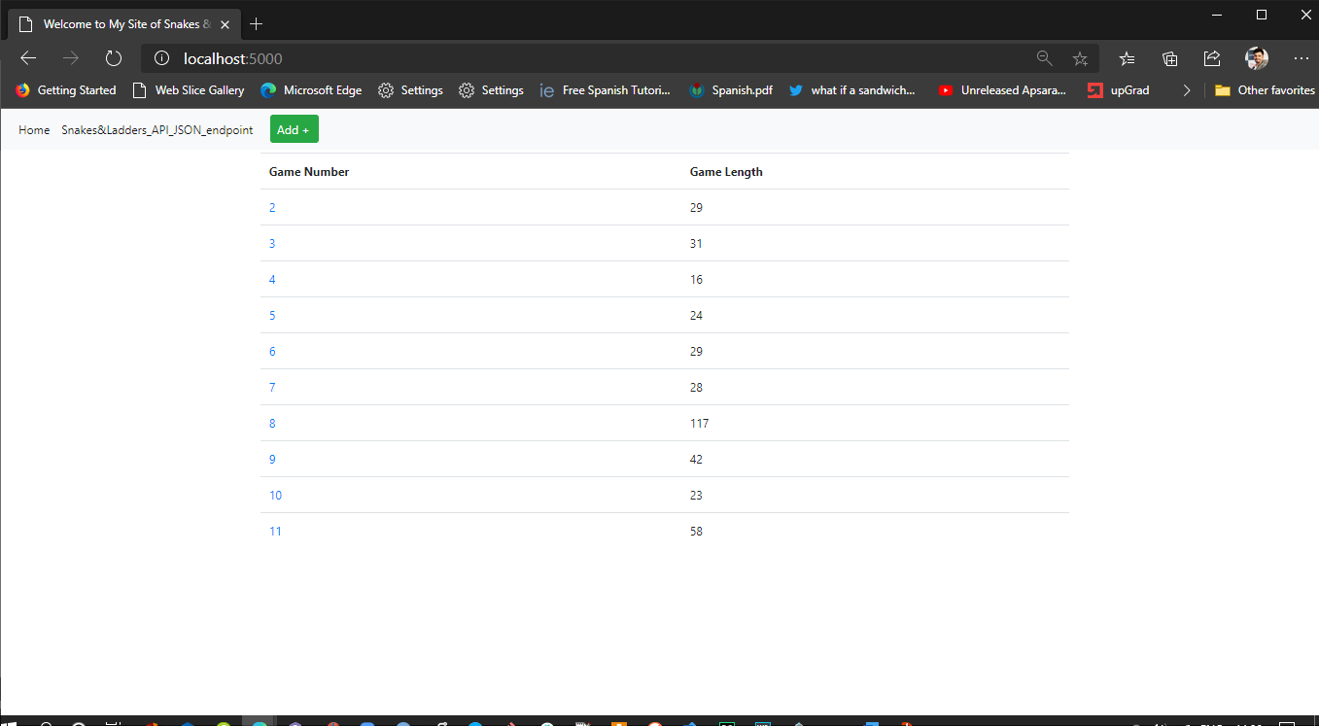

1. ***YOUR*** project running correctly in the browser displaying an updated record added to your home page

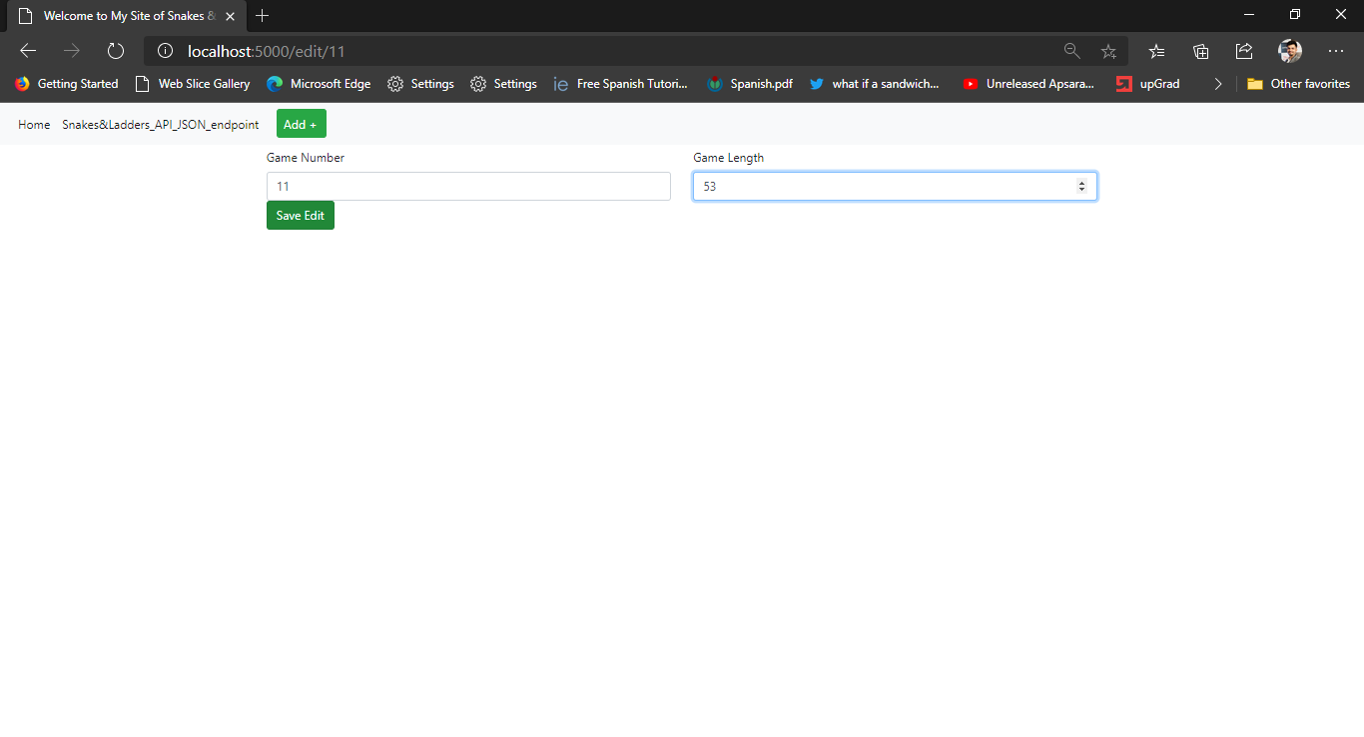

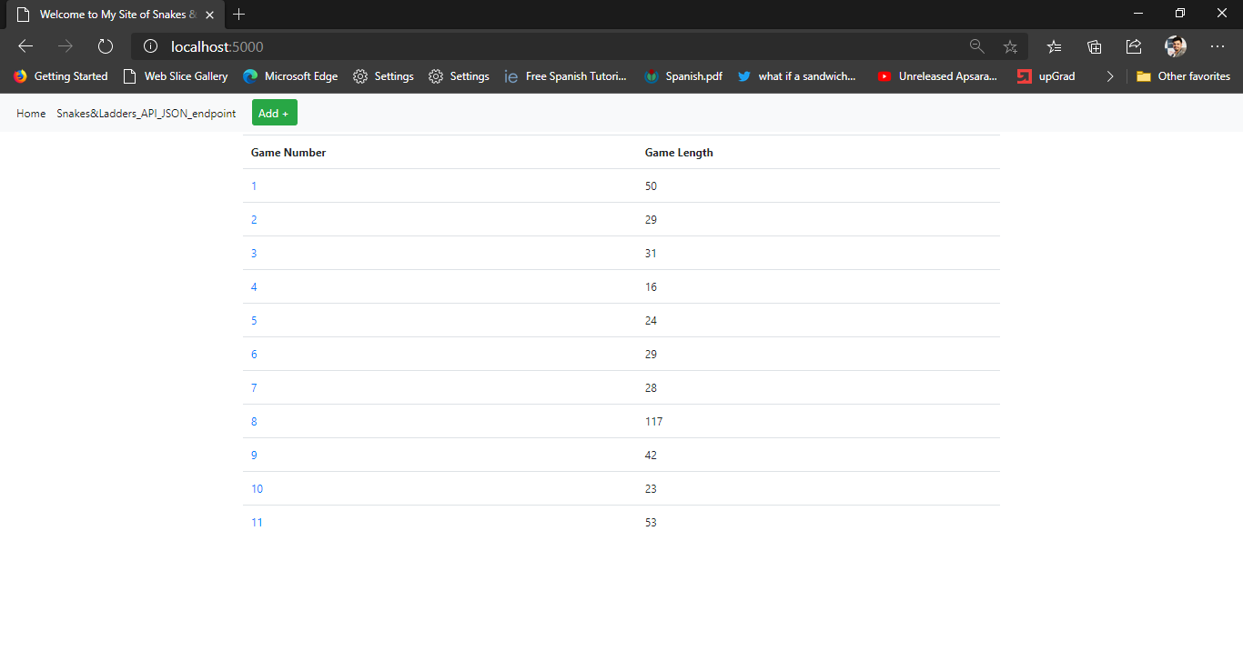

1. ***YOUR*** project running correctly in the browser displaying a deleted record added to your home page

*Added a new record for visible changes*

